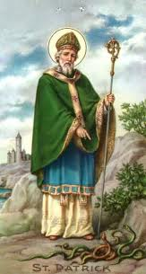
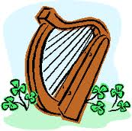
ST. PATRICK’S DAY PARADE
THURLES 2023

Entry Form Application

T
he St. Patrick’s Day Parade will take place on Friday 17th March 2023.
The parade will assemble at Abbey Road, Thurles at 1.45pm at Jysk Store and leave at 2.15pm.

The Thurles St. Patrick's Day Parade Committee are seeking your support by participating in the national event.
The theme of this years event is – Past Present & Future - and is open to interpretation by each club or organisation.
The success of the Parade over the years is due to the high levels of participation of local businesses, clubs, schools, residents’ associations and other organisations.

This year 2023, to mark the return of a live parade, the 1st Prize will be €1,000 for the best overall winner.
Prizes will be awarded as follows:
Total prize fund: €2,000.00.
Overall Winner: €1,000 Trophy Sponsor Supermacs Thurles
Runner Up Best Large Entry: €500 Trophy
Best Band Entry: €250 Trophy sponsor Michael Jewellers Thurles
Best School Entry: €250 Trophy sponsored by Thurles Shopping Centre
Various Category Prizes: 12 Prizes and 600 Medals

Tipperary County Council, Thurles Chamber of Commerce & Thurles Businesses are the main sponsors of the parade.
For further information please contact or text Chairperson Johnny Kenehan @ 0851974620 or email
thurlespaddiesday@gmail.com
or
Post To: The Secretary, Thurles St. Patrick’s Day Parade Committee,
c/o Thurles Tourist Office, Slievenamon Road, Thurles, E41C6W8.

Details of Entry_______________________________________________

Contact Name:_______________________________________________

Contact Number:______________________________________________

Company/Group/Organisation: __________________________________
_____________________________________________________________
Number of Children in Group (for Medals)_________________________
Address: _____________________________________________________

The Thurles St. Patrick's Day Parade Committee wish to Thank all our Participants and wish them continued success.

