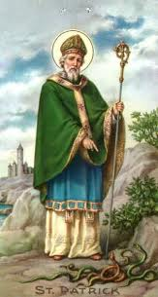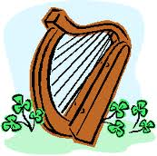 **ST. PATRICK’S DAY PARADE**

**THURLES 2025**

**Entry Form Application**

**T**he Thurles St. Patrick’s Day Parade will take place on Monday17th March 2025 and will assemble at Abbey Road, Thurles gathering at 1.30pm at Jysk Store leaving at 2.15pm. Tipperary County Council, Thurles Chamber of Commerce & Thurles Businesses are the main sponsors of the parade.

The Thurles St. Patrick's Day Parade Committee are seeking your support by participating in the national event. The success of the Parade over the years is due to the high levels of participation of local businesses, clubs, schools, residents’ associations and other organisations.

The theme of the 2025 Parade is **“Mythical Ireland, in the time of Saint Patrick”.** Or a theme of your choice. Entry is free and all are welcome to showcase your group or organisation.

Live Music, face-painting and side attractions in Liberty Square prior to and throughout the Parade.

**Prizes will be awarded as follows:**

**Total prize fund: €1,800.00.**

Overall Winner: €500. Trophy Sponsored by Michael’s Jewellers

Best Large Entry: €250. & Trophy Sponsored by Supermacs Thurles

Best Band Entry: €200. Trophy

Best School Entry: €200. Trophy sponsored by Thurles Shopping Centre

Various Category Prizes: 12 Prizes + Cash and 500 Medals

**For further information please contact or text Chairperson Johnny Kenehan @ 0851974620 or email entries to durlaseileparade25@gmail.com or hello@thurlestouristoffice.ie**

**Post To: The Secretary, Thurles St. Patrick’s Day Parade Committee,**

**c/o Thurles Tourist Office, Slievenamon Road, Thurles, E41C6W8.**

**Details of Entry: ...............................................................................................**

**Contact Name: ………………………………………………………………………**

**Contact Number: ……………………………………………………………………**

**Company/Group/Organisation: ....................................................................**

**...........................................................................................................................**

**Number of Children in Group (for Medals): ..................................................**

**Email Address: .........................................................................................................**

***The Thurles St. Patrick's Day Parade Committee wish to Thank all our Participants and wish them continued success.***